6/3/2021

Installation Guide & User Manual

Project 2: Automated Complaint Management Ticketing System

Done By:

* Jenil Rajendra Savani(30369469)
* Sanjeet Singh(30367076)
* Ravi Pun(30342838)
* Krunal Patel(30371366)

# Revision Chart

|  |  |  |  |
| --- | --- | --- | --- |
| **Version**  **Number** | **Date**  **Approved** | **Approved**  **by** | **Description** |
| 1.0 | 05-06-2021 | Teena Arora | Installation Guide and User Manual |

# 

# Purpose of The Document

The Document title “Installation Guide and User Manual” itself Identifies the purpose of the document. Document contains brief details on what are the number of pre-requisite software, it gives step by step details on installation of the software’s with the use of appropriate images. After the installation of the of the required the software, the website starts running. To give some knowledge to the users regarding the functioning of the website, a user manual is placed into this document which clearly defines each function of the website where a user interacts with the system. There are mainly three users for this website which is Admin, user and cloud engineer. Each user does different functionality and have separate dashboard therefore, each of the functionality can be learnt from this document.

Table of Contents

Revision Chart 1

Purpose of The Document 2

Brief Overview of the Project 4

GLossary 4

Installation Guide 5

Required Software 5

Installation Steps 5

User Manual 7

Registration 7

User Registration 7

Cloud Engineer Registration 8

Admin Registration 8

Login 9

User Roles 10

User Role 10

Lodge Complaint in User Dashboard 10

Complaint Status displayed in the User dashboard. 11

User Complaint History 11

Change Profile Setting 13

Access FAQ Page 13

User Logout 14

Admin Role 14

Manage user Complaints 15

Assigning New Complaints to a Cloud Engineer 15

Edit Department 17

Edit Category 18

Manage Users 18

Admin Logout 18

Cloud Engineer Role 19

Manage Assigned user Complaints. 19

Cloud Engineer Logout 22

# Brief Overview of the Project

Our Client Mr. Prashant Maharjan is supporting a cloud service provider. The users of his service face many unexpected issues such as failed connectivity and many other such things. In such situation, the users need to email (in form of ticket) the technical person. This process is inefficient for the cloud users as it is very slow and sometimes help is not done at the point of time, in addition to this it is hard for the technical person to keep record of tickets; hence our client plans to build a system which will allow the users to create tickets directly into the system, instead of using emails.

Therefore, Our Automated Complaint Management ticketing system will be overcome those problems faced by the cloud service users. This complaint management ticketing system is built in such a way that every IOS and Windows user can operate it. For solving the issue, the cloud user needs to register into the systema and then needs to login where he can lodge a complaint using a complaint form where he gets a ticket no. For Tracking the complaint, he can view the complaint status form its dashboard itself. Admin assigns the new complaint to the cloud engineer and then the cloud engineer communicates with the user from the same web portal and resolves the complaint.

# Glossary

|  |  |
| --- | --- |
| Name | Description |
| Git | Github repository offers the distributed version control and source code management functionality on the internet platform |
| XAMPP | XAMPP is a free and open-source cross-platform web server solution stack package developed by Apache Friends, consisting mainly of the Apache HTTP Server, MariaDB database, and interpreters for scripts written in the PHP and Perl programming languages. |
| Repo | Repository is spelled as repo, repository determines the storage location of files and software used in the project |

# Installation Guide

For this app we will need XAMPP to setup the database MySQL and Apache Web server to run the php file.

## Required Software

* XAMPP
* Git

## Installation Steps

* After installing Git and XAMPP clone the repo in the htdocs folder.
* For MacOS go to Users/username/Application/XAMPP/htdocs

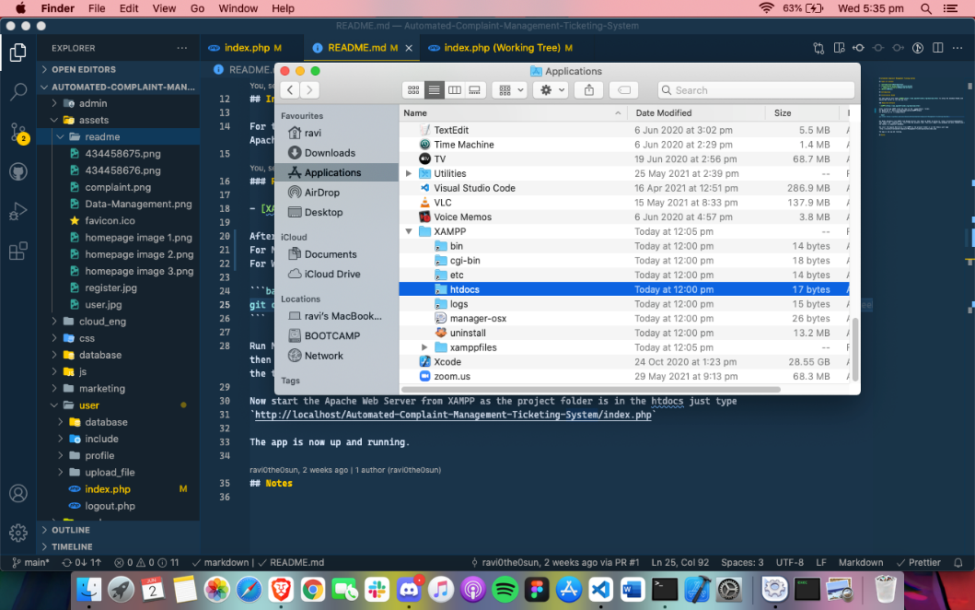

* For Windows go to C:/xampp/htdocs

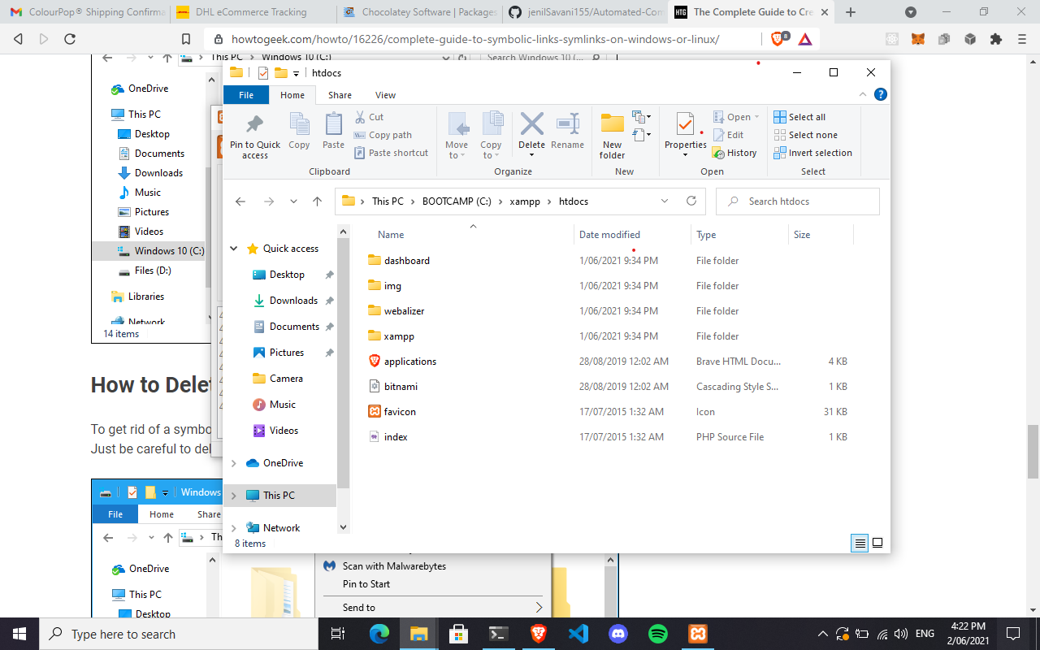

* Git clone https://github.com/jenilSavani155/Automated-Complaint-Management-Ticketing-System
* Run MySQL Database and Apache Server from XAMPP on Manage Servers tab.

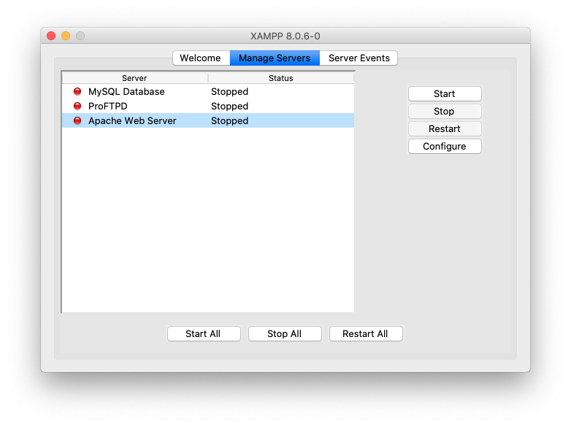

* Open up MySQL by going to <http://localhost/phpmyadmin/> then import the **complaint.sql** file in this URL <http://localhost/phpmyadmin/index.php?route=/server/import> from the projects root folder. This will import the database we have created and all the tables in complaint database.

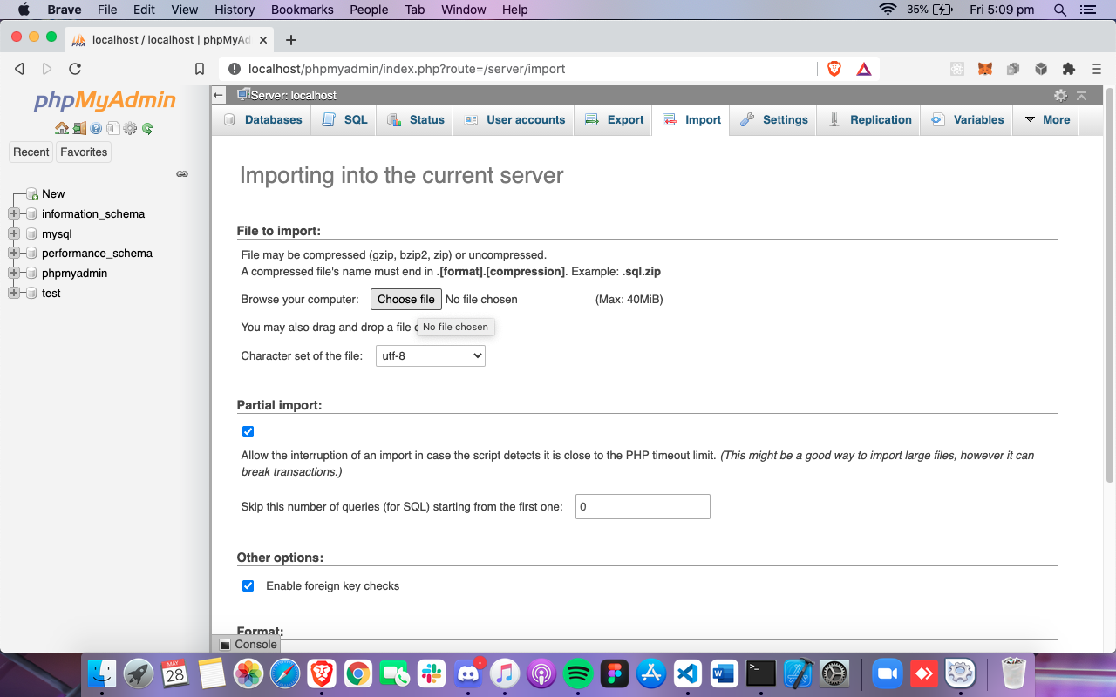

* Now go to <http://localhost/Automated-Complaint-Management-Ticketing-System/index.php>
* The app is now up and running.
* For hosting on the cloud please follow this document from official XAMPP website

# User Manual

* Go to <http://localhost/Automated-Complaint-Management-Ticketing-System/index.php> Where you will be greeted by our Homepage.

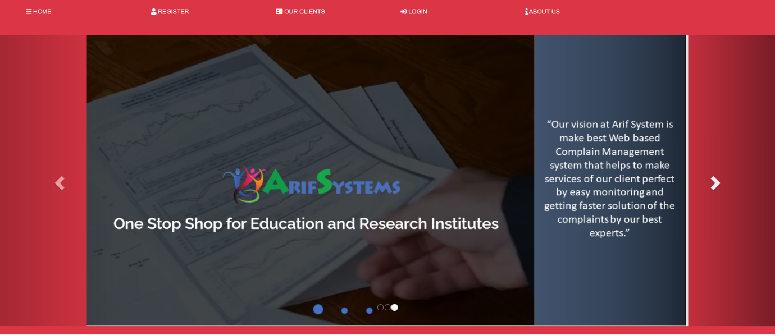

* As requested, but the client we have divided the users in three different roles with different levels of authorities and functionalities.

## Registration

You can register as a User or a Cloud Engineer by entering

### User Registration

* For Registration of the User, please click on to the registration button which is there on the homepage navigation button.
* On filling up the registration details (i.e. Full_name, Email_address, password) please select the “User” in the scroll bar where we need to select two options out of one.
* Click on to the registration button where you will get a notification on successful registration which is as defined below:

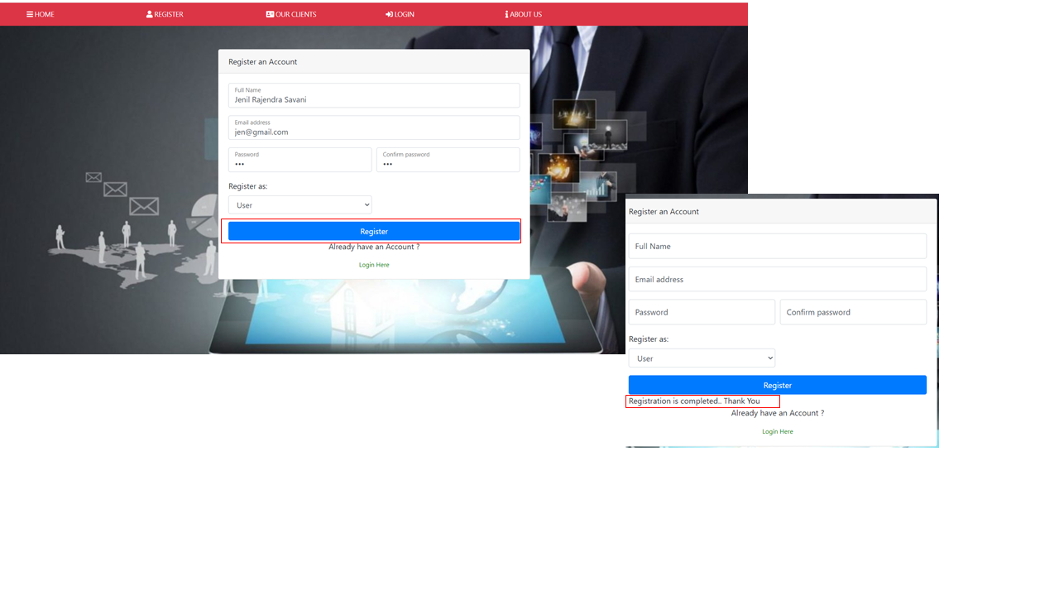

### Cloud Engineer Registration

For a cloud engineer you can follow the above user registration but change the Register as to **Cloud Engineer.**

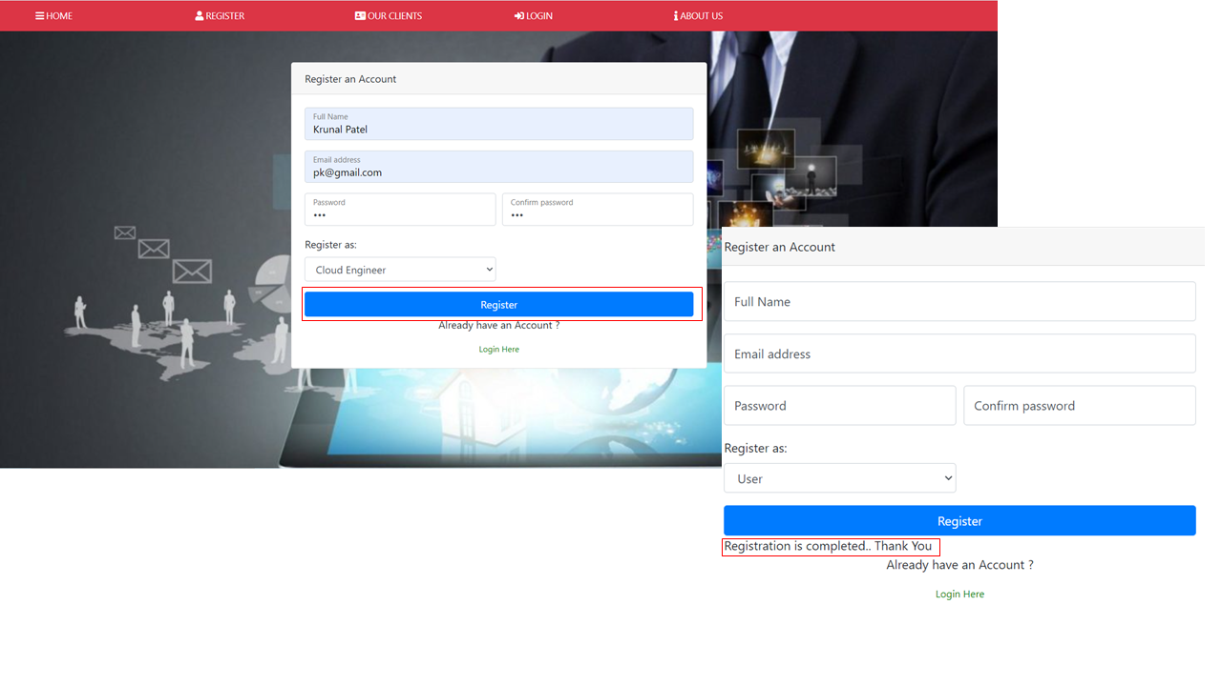

### Admin Registration

* For Admin we recommend having them register right after they are registered. For this we will have to go through MySQL to add them. Go to <http://localhost/phpmyadmin/index.php?route=/sql&server=1&db=complaint&table=admin&pos=0> this is the table for admin accounts.
* Click on **Insert tab** on the **Dashboard** to add a new admin.



* After that add the username, full_name and the MD5 encrypted string of the password the admin wants for the account as shown below. For encryption we recommend this [website](https://www.md5online.org/md5-encrypt.html).

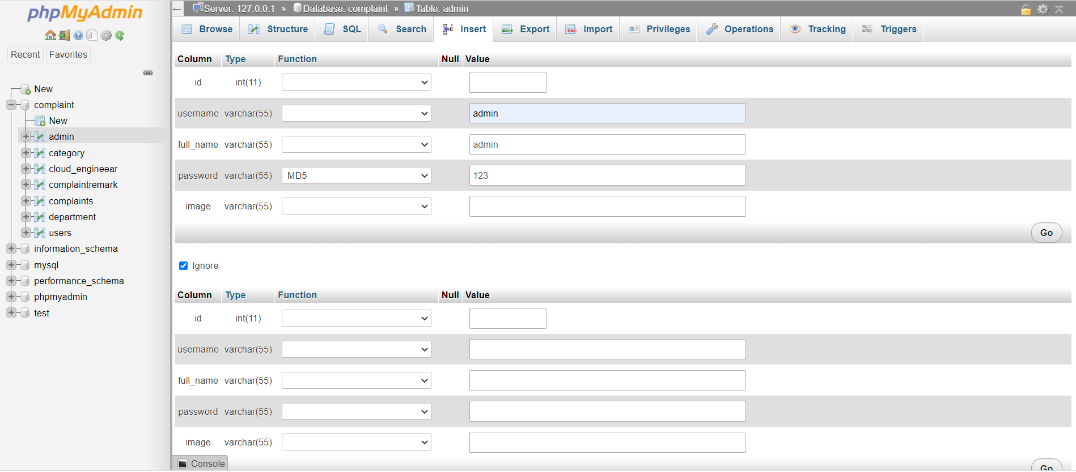

* click go which is at the end to add that account.

## Login

* For Login go to [http://localhost/Automated-Complaint-Management-Ticketing-System/login.php](http://localhost/Automated-Complaint-Management-Ticketing-System/login.php%20) . For Users and Cloud Engineer you will have to use the email you have used to register and the password for that account you setup. Remember to login as a User please make sure the Login As has User selected as so with the Cloud Engineer make sure it is Cloud Engineer.

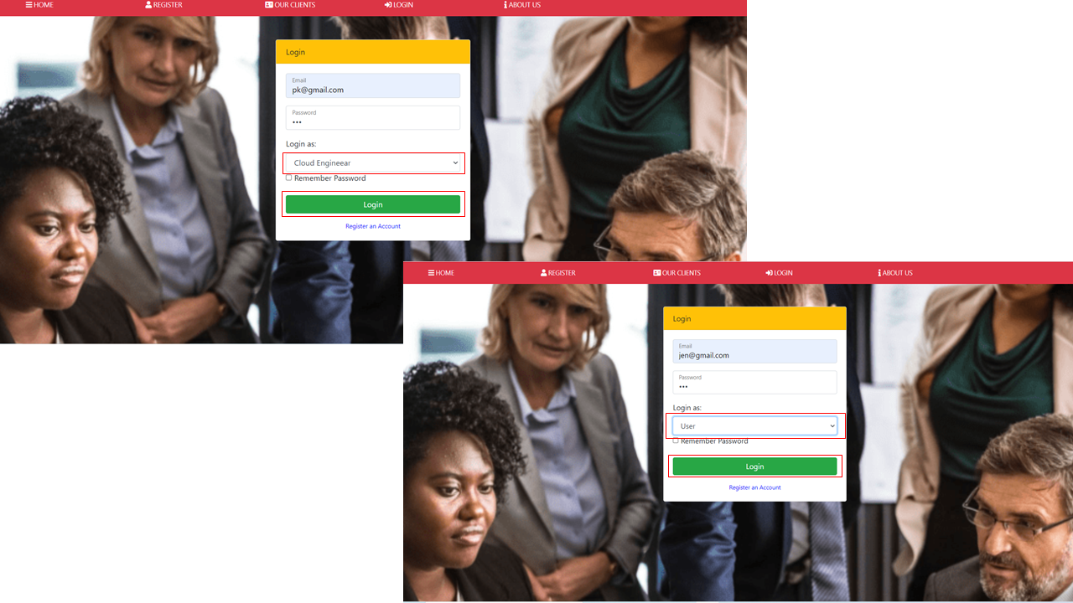

* For Admin you will have to use Username for that profile and the password for it and don't forget to make sure you Login as an Admin.

# User Roles

As discussed above we have divided user roles into three main categories in this Website having different authorities respectively.

## User Role

* On successful login of user, user dashboard is displayed which is as follows:

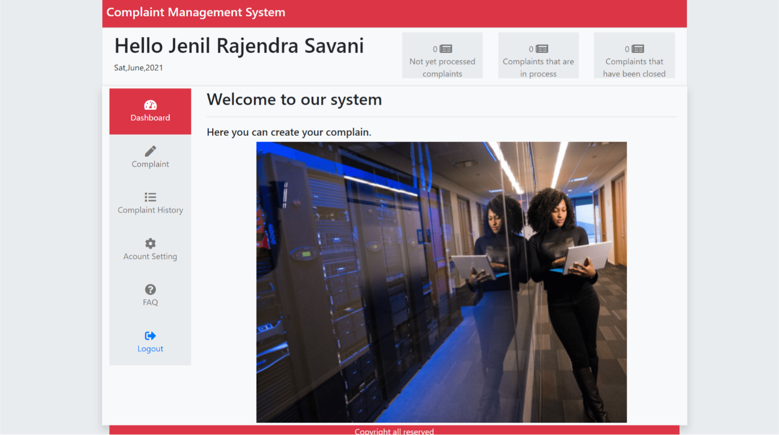

### Lodge Complaint in User Dashboard

* For Lodging a complaint into the system, please click on to the complaint symbol as displayed into the user dashboard.

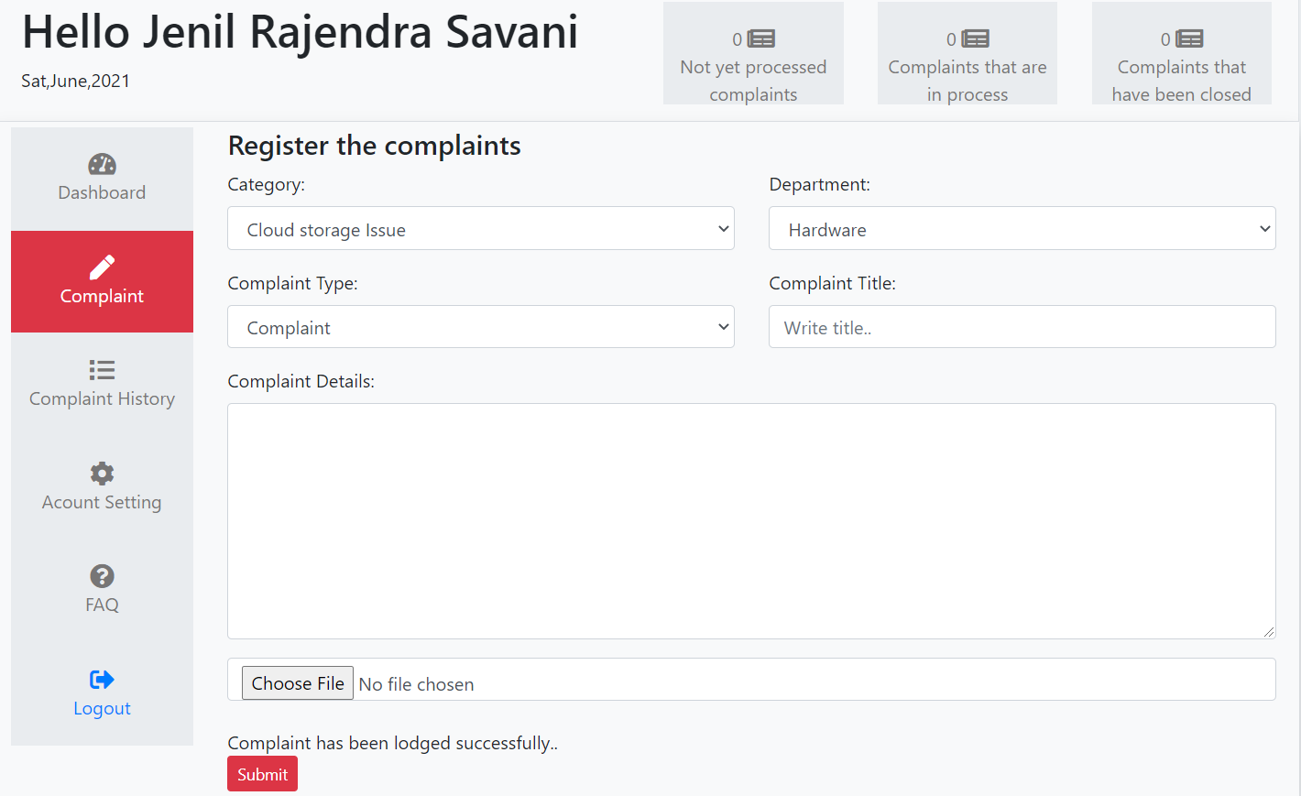

* Please Select the different categories and department where there is issue with. After selecting those things, please enter the Complaint title and complaint details and then click onto the submit Button.
* On successful lodgement of the complaint a notification is of successful complaint registration is displayed.

### Complaint Status displayed in the User dashboard.

After lodging the complaint by the user, the status of the complaint is displayed on the status bar which is placed at the top.

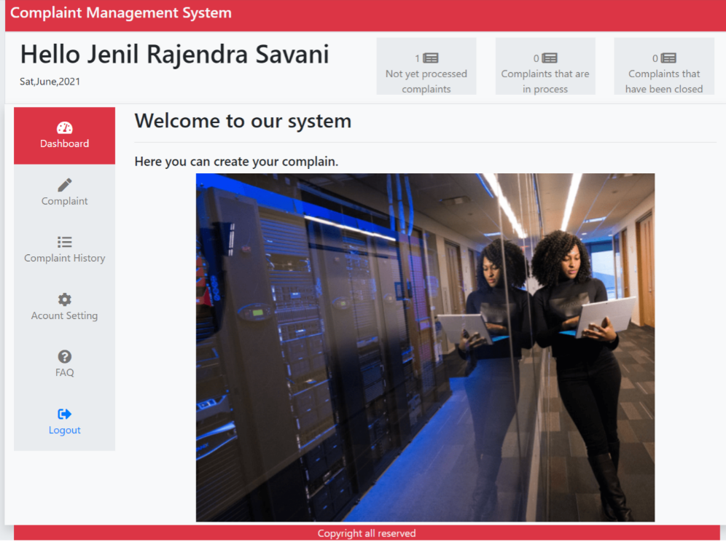

### User Complaint History

* To view the lodged complaints, click on to the complaint history button displayed into the navigation button on the user dashboard.

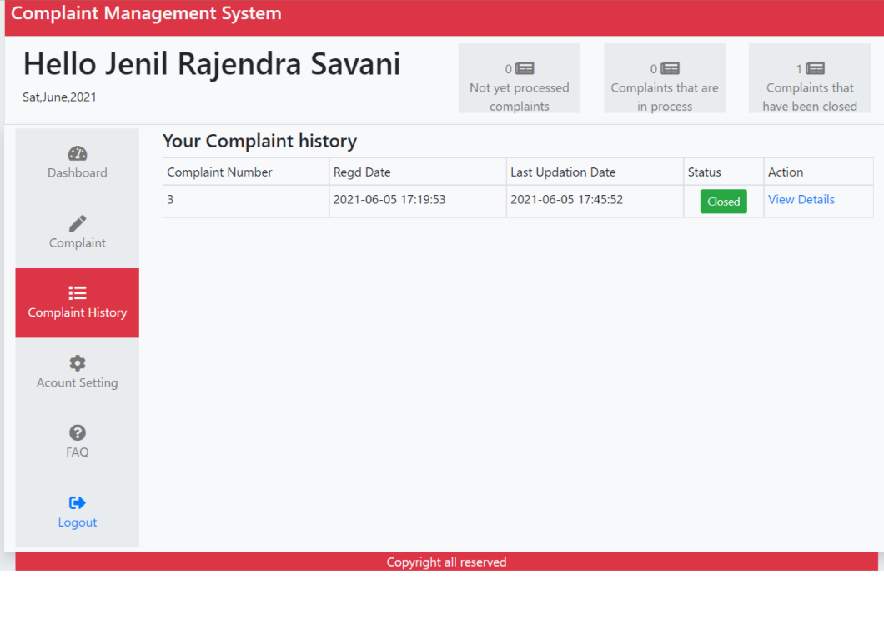

* To view the details regarding the complaint please click on to the **View Details** button.
* The following screen is displayed on clicking the view Details button:

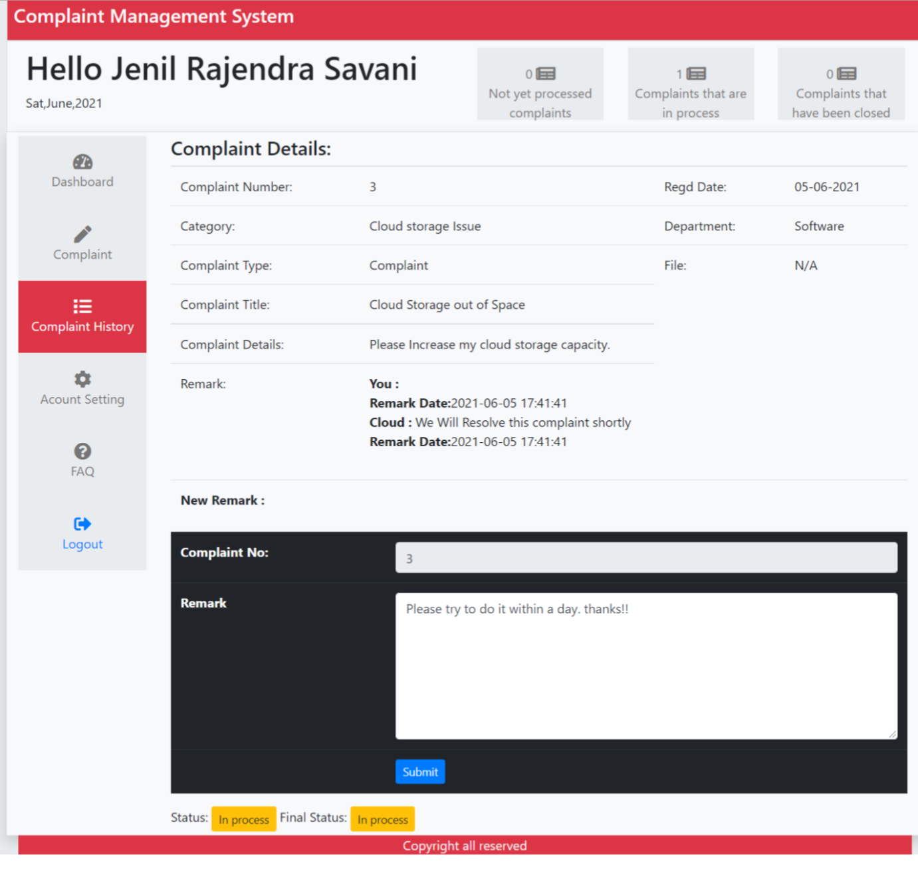

* In this screen, complaint details including Complaint_type, Complaint_title, Complaint_Number, Complaint_details, and remarks are displayed.
* User can also access the messaging through entering the message into the remark section and submit it by clicking the submit button: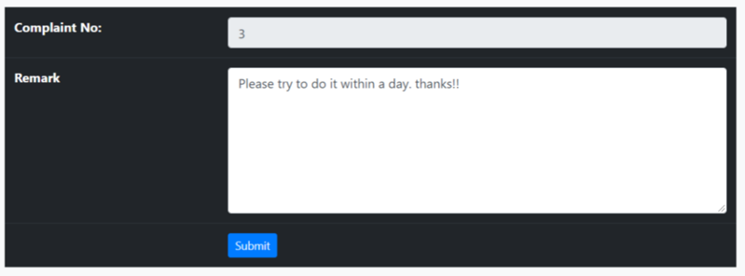

### Change Profile Setting

* To change the profile setting click on to the Account Setting button on the user dashboard.
* User can change his/her name and can update his or her profile image.
* After changing the things, User need to click on the update button to successfully update the details.

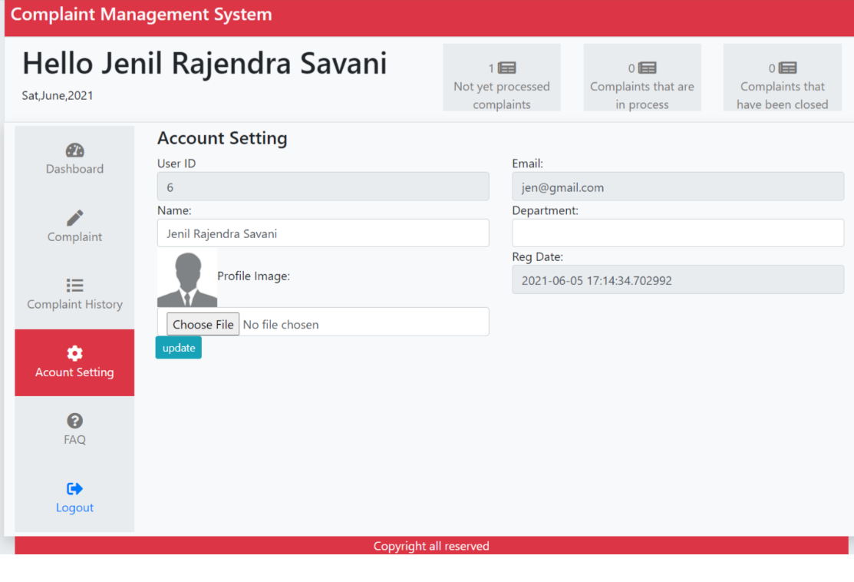

### Access FAQ Page

To access the FAQ page, please click on to the FAQ button on the side navigation panel of User dashboard which is as shown below:

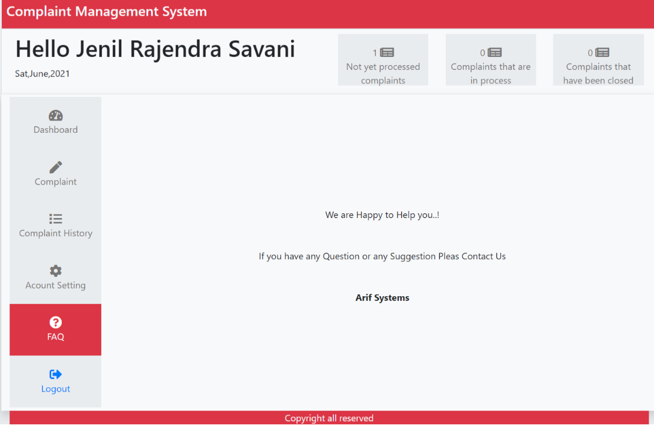

### User Logout

* To logout from the system, user needs to click on the logout button which placed on the last side of the navigation button. The Logout button is displayed below:



## Admin Role

* On successful login of Admin, Admin dashboard is displayed which is as follows:

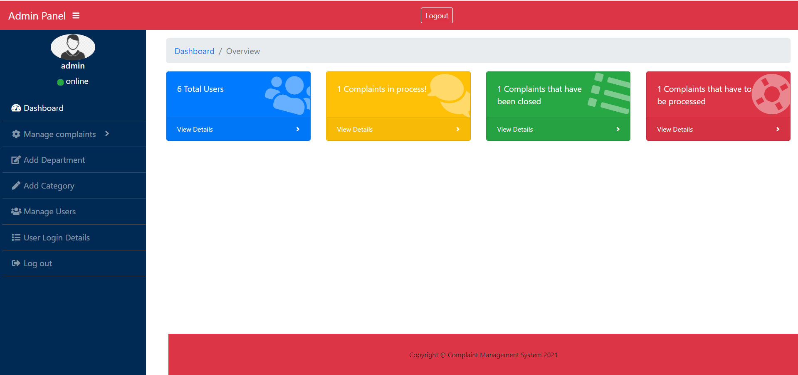

### Manage user Complaints

* To Manage new complaints, Admin can manage complaints by clicking onto the manage complaint button which is on the side navigation bar, or he can directly click onto the complaint status bar present on the main dashboard.
* The following displays the no. of ways one can manage the complaints:

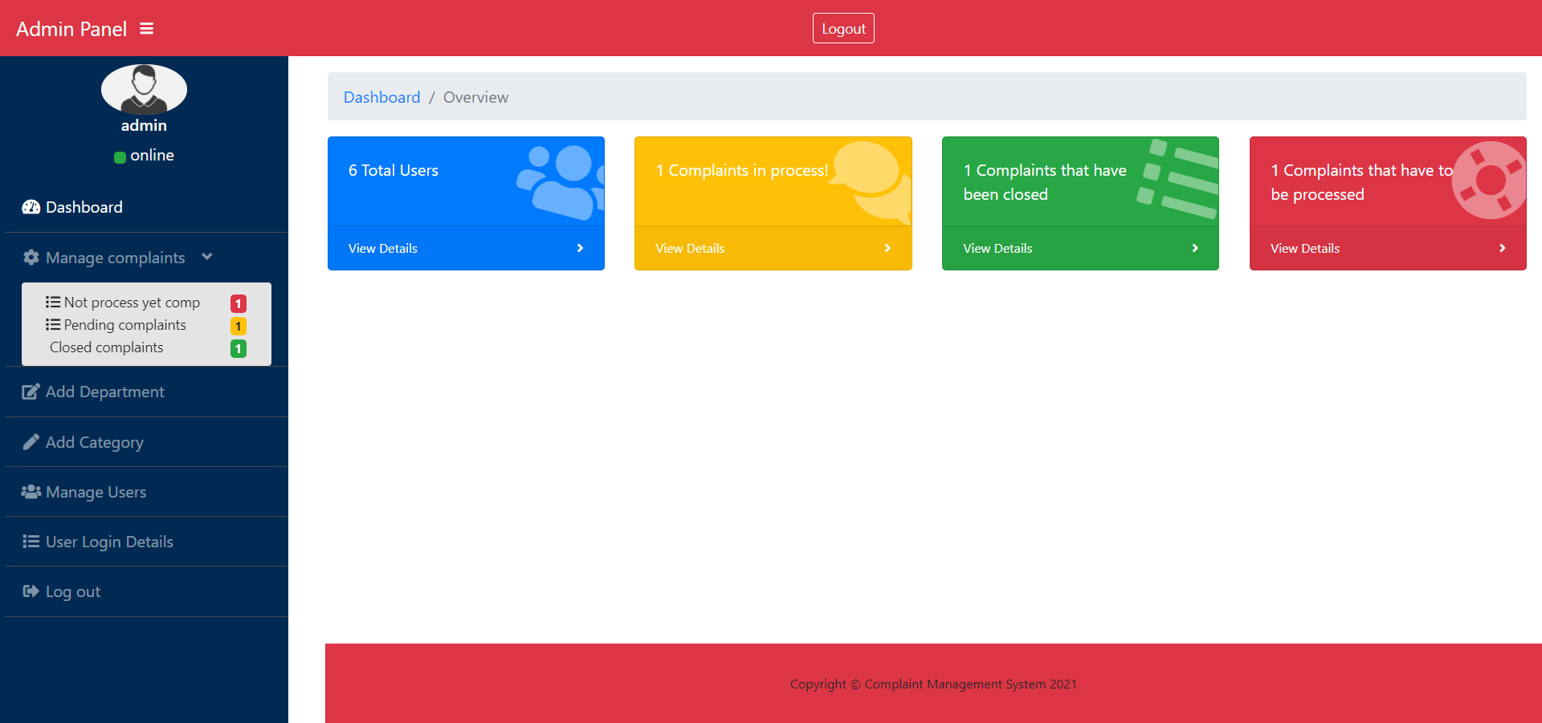

### Assigning New Complaints to a Cloud Engineer

* For Assigning new complaints to a cloud Engineer, Admin needs to click on to the “red status bar” or select the “manage complaints” button and then click on to “Not process yet comp”. On clicking those links, the following page is displayed:

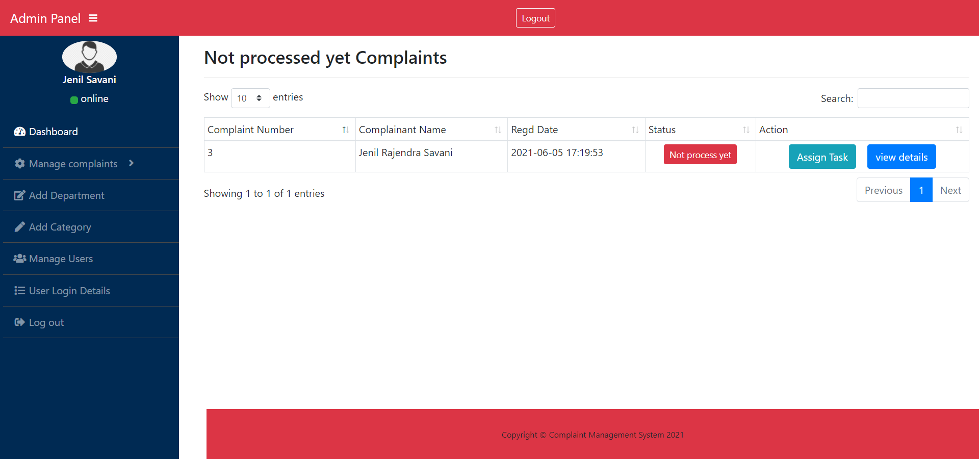

* To assign cloud engineer, Admin first view the details of the complaint by clicking on to the “view details” button which is there in Blue coloured.

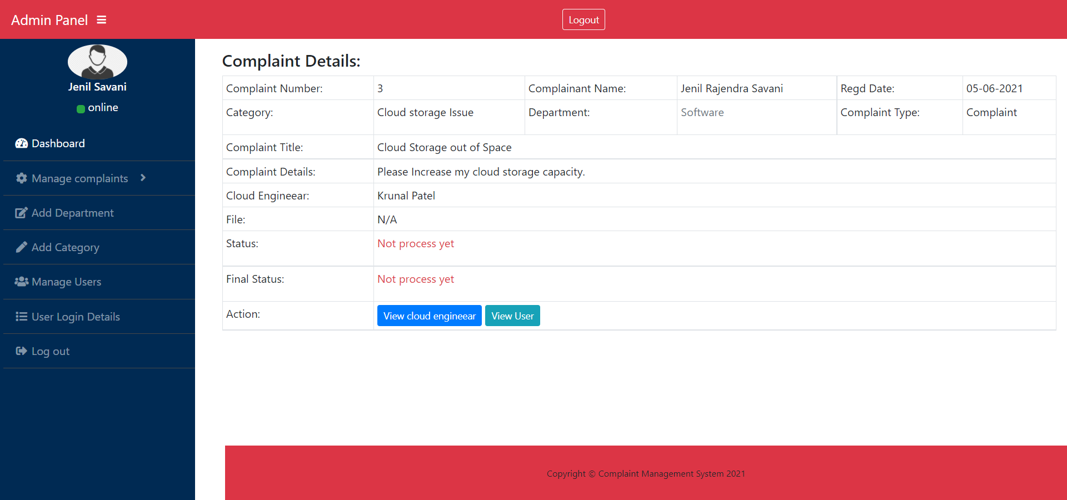

* After Viewing the complaint details, Admin can now assign the complaint to a specific cloud engineer by clicking on to “Assign Task” Button which is placed next to not processed yet complaint button.

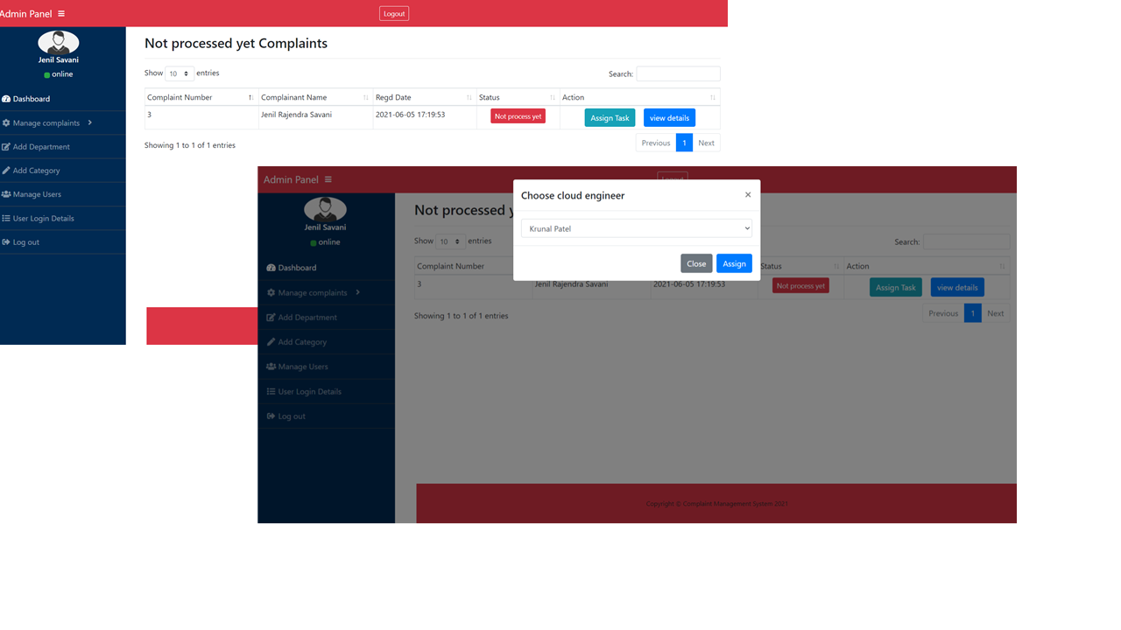

### Edit Department

* Admin has the authority to manage the department categories from his own dashboard.
* To access this functionality, Admin needs to click on to the “Add Department” button which is located in admin’s dashboard through the side navigation panel.
* On the next screen Admin can do the following tasks:
  + Delete the predefined department categories by clicking on to the red “Delete” button.
  + Admin can edit those department categories by clicking on to the “edit” button.
  + Admin can add the department by entering the department name and then clicking onto the “create” button.

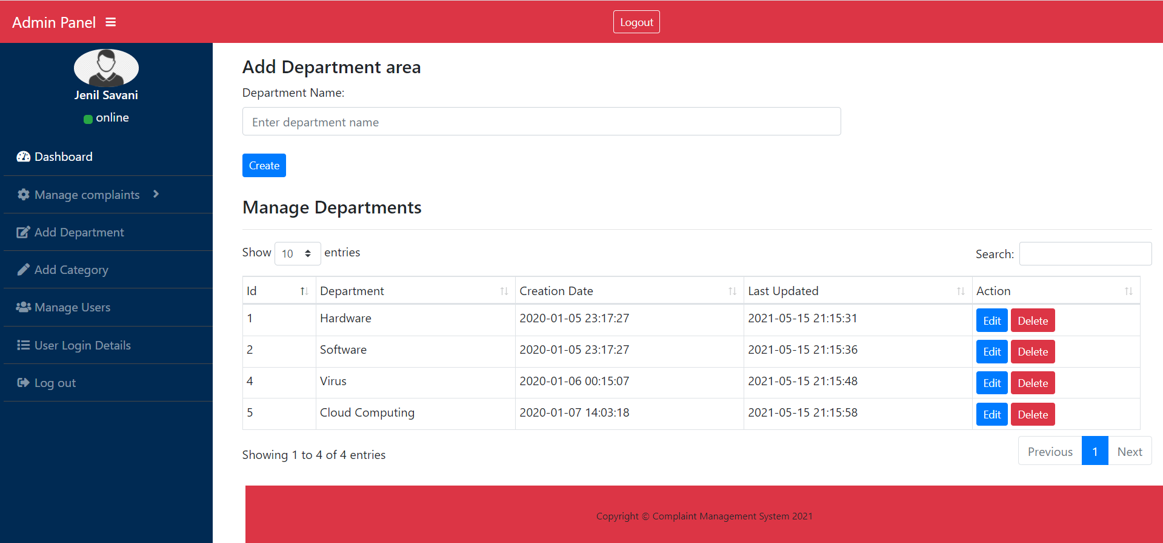

### Edit Category

The category can be managed in same way as “department” is managed. The only thing that admin needs to do is to click on the “add Category”. 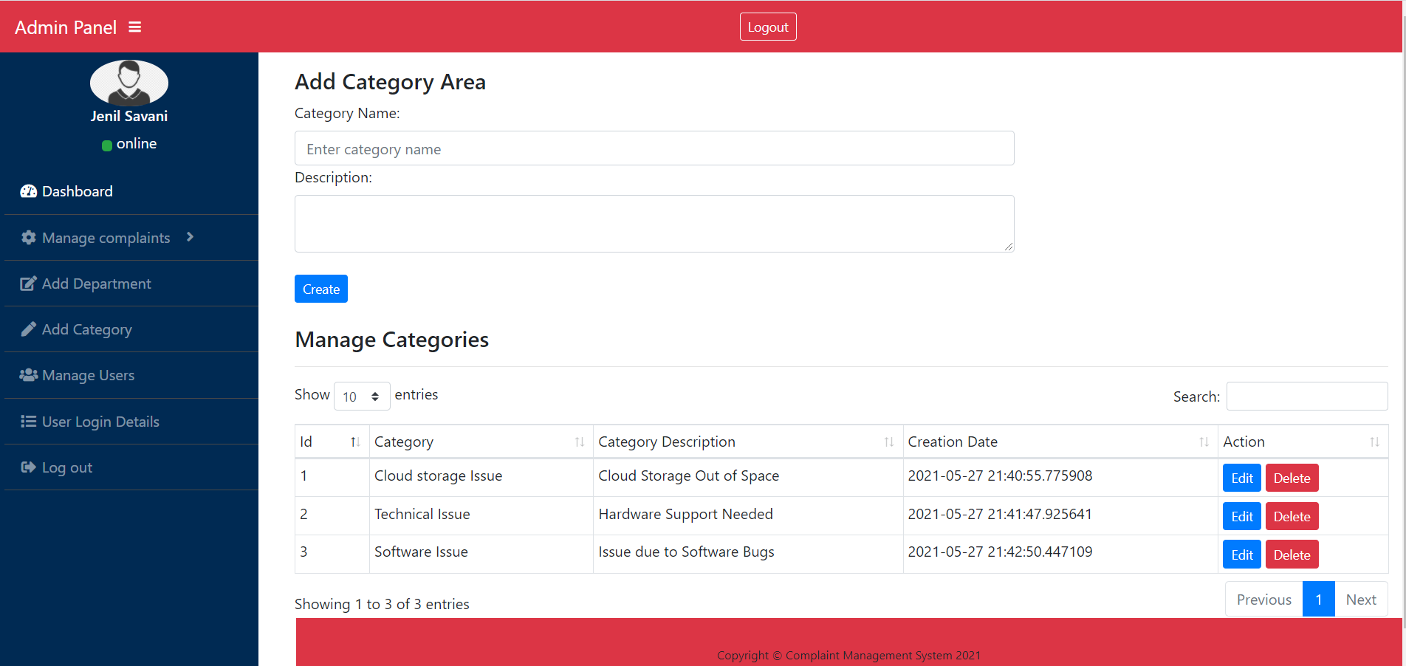

### Manage Users

* Admin has the authority to manage the user, which means Admin can Remove or view the users from the database or from the system.
* To remove the users from the database, admin needs to click onto the “delete” button in the manage user page.
* While to view the User Details, Admin needs to click onto the “View details” link.

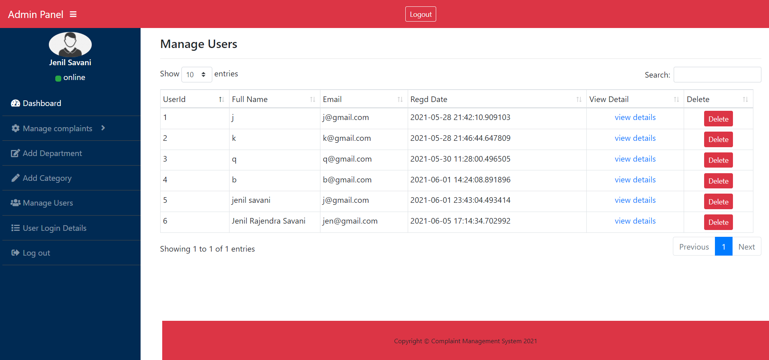

### Admin Logout

* For Admin to logout form the system, he can access the logout feature from two places:
  + Admin can click on the “logout” button which is placed on the top of dashboard.
  + On the other hand, Admin can logout by clicking the “logout” button placed on the side navigation panel of the admin dashboard.



## Cloud Engineer Role

After Successful Login of Cloud Engineer, Cloud Engineer dashboard is displayed which is as follows:

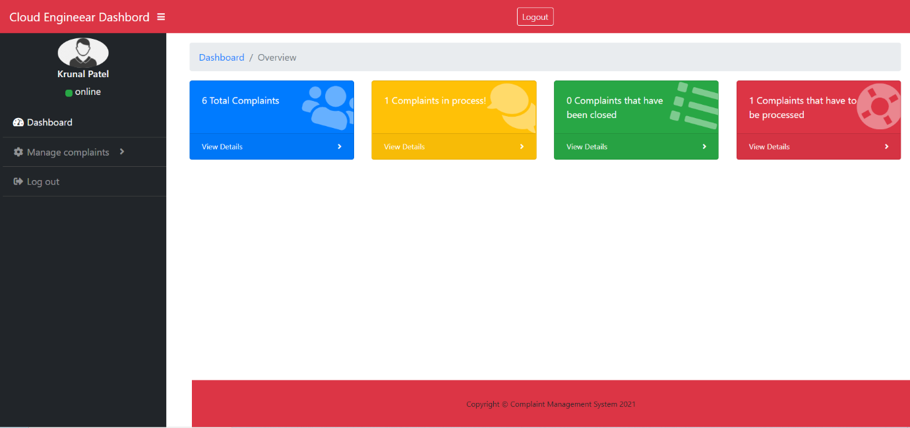

### Manage Assigned user Complaints.

* To Manage assigned complaints, Cloud Engineer can manage complaints by clicking onto the manage complaint button which is on the side navigation bar, or he can directly click onto the complaint status bar present on the main dashboard.
* The following displays the no. of ways one can manage the complaints:

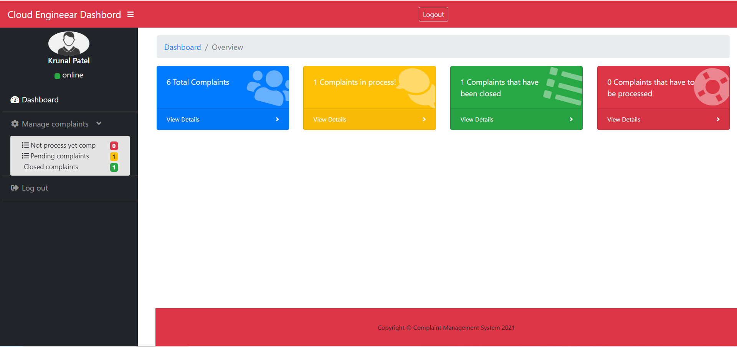

* If an admin recently assigns a new complaint to the cloud engineer, then this complaint is displayed in the red colour status bar in the cloud engineer’s dashboard.
* If the complaint is already assigned to the cloud engineer and it is in progress, then that complaint is displayed with yellow colour status bar in cloud engineer’s dashboard.
* If the assigned complaint is already resolved by the cloud engineer, then that complaint is displayed with green colour status bar in cloud engineer’s dashboard.

#### Manage Not Yet Process Complaints

* To manage or access the new complaint, cloud engineer needs to click onto the red colour status bar in the dashboard and after that a new page is displayed.
* In the not yet process page, Cloud engineer needs to click onto the “view details” button to further view detailed information regarding the issue which user faces.
* The following displays the Not yet process page:

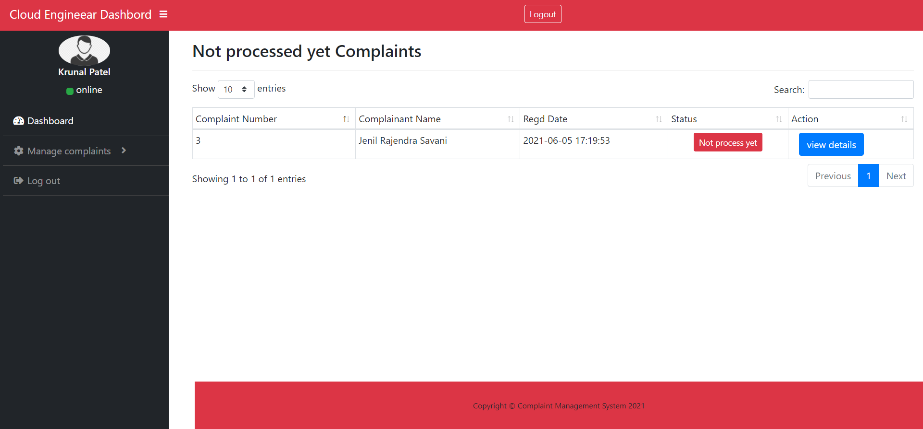

* On clicking onto the “view details” button, the following page is displayed.
* Cloud Engineer reads out the issue which user faces.
* After thorough reading Cloud Engineer clicks on to the “Action” button where he further decides whether to close the complaint if the complaint is invalid or to make it in progress if it is valid.
* Along with this action, he also adds remarks or send message to the user about the issue or the progress of the complaint.

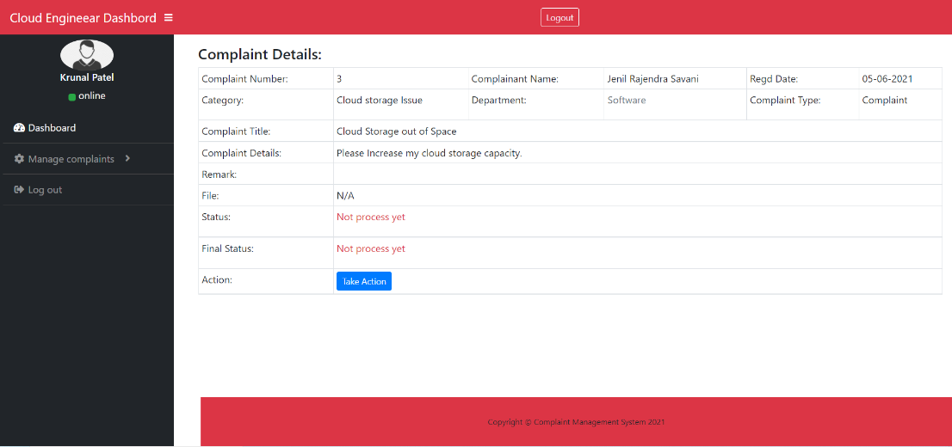

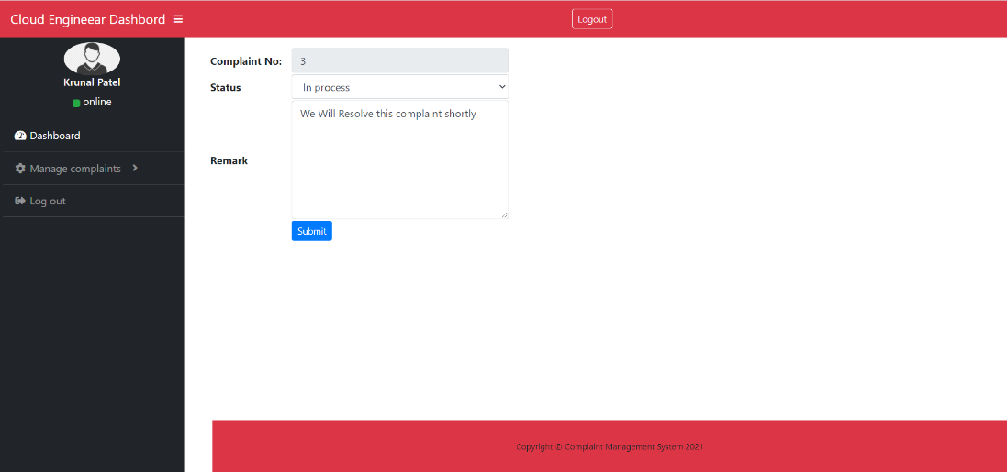

#### Manage “In Progress” Complaints

* The in-progress complaint can now be access via yellow status bar button which is there in the cloud engineer dashboard.
* On clicking onto the yellow status bar button, a database is displayed where cloud engineer can see each of the “In progress” complaints.
* Cloud engineer needs to click on to “view details” with specific complaint,
* On clicking on to that link the following screen is displayed where cloud engineer can see the user messages and can take action to close the complaint by entering the remarks.

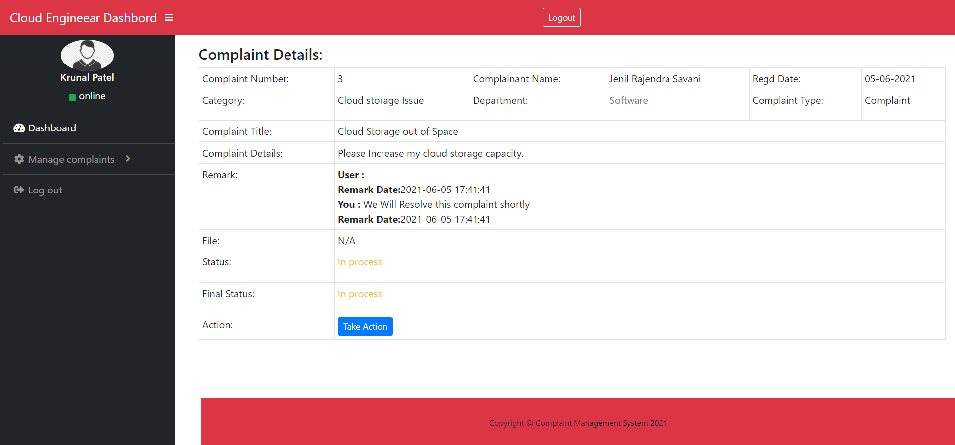

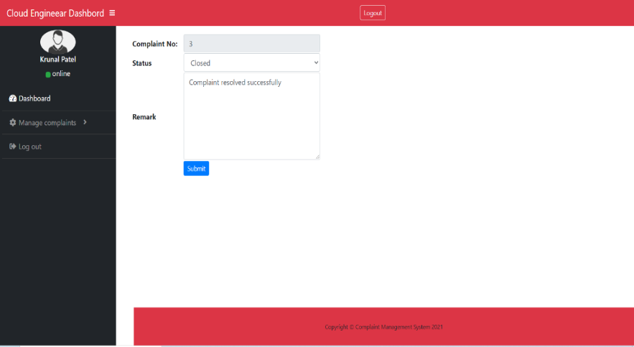

### Cloud Engineer Logout

* To logout from the system, Cloud Engineer needs to click on the logout button which placed on the last side of the navigation button. The Logout button is displayed below:

